**EXPERIMENT 5**

**AIM:** To write an assembly program to sort numbers in ascending order

**Prerequisite**: TASM assembler

**Theory:**

Firstly we need to load all the contents that are needed to be arranged in ascending order to register CL.Then we need to travel from the memory location to compare the two numbers. If the first number is greater than the second number then there will be a swap. Then we need to fix the position for the last number and also decrease the count by 1. Again start checking and comparing till all the numbers are checked. After running the program we can see the ascending order in the dump.

**ALGORITHM:**

1. Load data from offset 500 to register CL (for count).
2. Travel from starting memory location to last and compare two numbers if the first number is greater than the second number then swap them.
3. First pass, fix the position for last number.
4. Decrease the count by 1.
5. Again travel from starting memory location to (last-1, by help of count) and compare two numbers if the first number is greater than the second number then swap them.
6. Second pass fixes the position for the last two numbers.
7. Repeat

**CODE:**

.MODEL SMALL

.DATA

TABLE DB 9,7,5,6,5,1

VAL1 DB 5

NL DB ' ','$'

.CODE

MAIN PROC

MOV AX,@DATA

MOV DS,AX

LEA BX,TABLE

MOV DL,VAL1

LBL1:

LEA BX,TABLE

MOV CL,5

LBL2:

MOV AL,[BX]

MOV DL,[BX+1]

CMP AL,DL

JB LBL3

MOV [BX],DL

MOV [BX+1],AL

LBL3:

INC BX

LOOP LBL2

MOV DL,VAL1

DEC DL

MOV VAL1,DL

CMP DL,00

JNE LBL1

MOV CL,6

LEA BX,TABLE

DISPLA:

LEA DX,NL

MOV AH,09H

INT 21H

MOV DL,[BX]

ADD DL,30H

MOV AH,02H

INT 21H

INC BX

LOOP DISPLA

MOV AH,4CH

INT 21H

MAIN ENDP

END MAIN

**OUTPUT:**

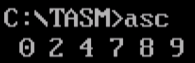

**Conclusion**:

From the above experiment we are able to arrange the given numbers in the program and set it in ascending order. Also to check the output we need to enter ‘td ascend.exe’ and run the program. From the view option, we need to select the dump so that the contents are seen in ascending order.

**AIM:** To write an assembly program to sort numbers in descending order

**Prerequisite**: TASM assembler

**Theory:**

Firstly we need to load all the contents that are needed to be arranged in descending order to register CL.Then we need to travel from the memory location to compare the two numbers. If the first number is smaller than the second number then there will be a swap. Then we need to fix the position for the last number and also decrease the count by 1. Again start checking and comparing till all the numbers are checked. After running the program we can see the descending order in the dump.

**ALGORITHM:**

1. Load data from offset 500 to register CL (for count).
2. Travel from starting memory location to last and compare two numbers if the first number is smaller than the second number then swap them.
3. First pass, fix the position for last number.
4. Decrease the count by 1.
5. Again travel from starting memory location to (last-1, by help of count) and compare two numbers if the first number is smaller than the second number then swap them.
6. Second pass fix the position for the last two numbers.
7. Repeat.

**CODE:**

DATA SEGMENT

STRING1 DB 99H,12H,56H,45H,36H

DATA ENDS

CODE SEGMENT

ASSUME CS:CODE,DS:DATA

START: MOV AX,DATA

MOV DS,AX

MOV CH,04H

UP2: MOV CL,04H

LEA SI,STRING1

UP1:MOV AL,[SI]

MOV BL,[SI+1]

CMP AL,BL

JNC DOWN

MOV DL,[SI+1]

XCHG [SI],DL

MOV [SI+1],DL

DOWN: INC SI

DEC CL

JNZ UP1

DEC CH

JNZ UP2

INT 3

CODE ENDS

END START

**OUTPUT:**

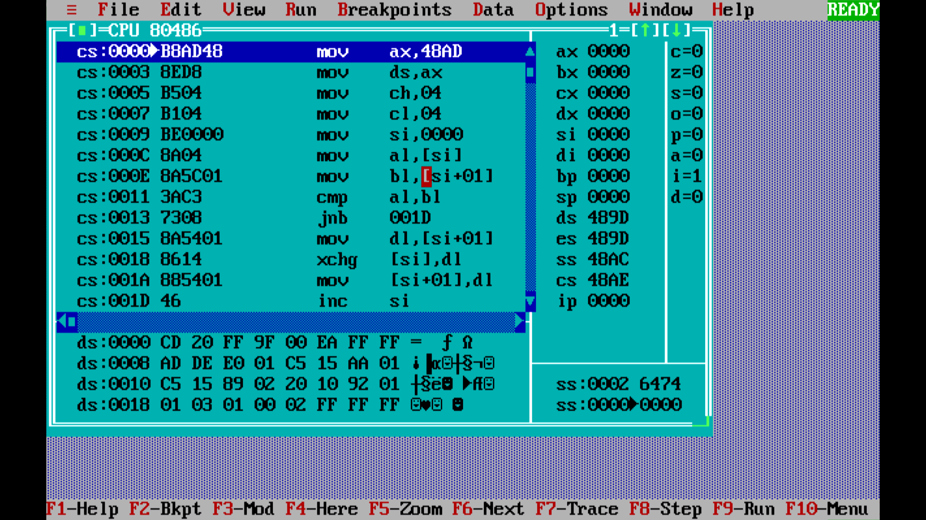

**Conclusion:**

From the above experiment we are able to arrange the given numbers in the program and set it in descending order. Also to check the output we need to enter ‘td descend.exe’ and run the program. From the view option, we need to select dump so that the contents are seen in descending order.